
AP Biology
Unit 5: Heredity
Suggested Duration: 10 Days
HEREDITY
UNIT PLAN

Table of Contents
UNIT NARRATIVE 1
ENDURING UNDERSTANDINGS AND CONTENT STANDARDS 2
ROADMAP 4
UNPACKED STANDARDS 12
VOCABULARY GLOSSARY 13

UNIT NARRATIVE
Unit 5 focuses on heredity and the biological concepts and processes involved in ensuring the continuity of life. Students learn that the storage and transmission of genetic information via chromosomes from one generation to the next occur through meiosis. Meiotic division ensures genetic diversity, which is crucial to the survival of a species. In this unit, students gain a deeper understanding of Mendelian genetics and learning how non-Mendelian genetics describes those patterns of inheritance that seem to violate Mendel’s laws. This unit also teaches the role played by chromosomal inheritance, environmental factors, and non-disjunction on an individual’s phenotype. In Unit 6, students move on to learn about gene expression and regulation.

Data can convey important information about biological systems. In order to understand that information, students need to practice describing data and then identifying and describing the patterns and trends that might make the data meaningful for the researcher and possibly lead to the discovery of new information or the development of new concepts. Comparing patterns and trends in data helps students describe biological changes that occur over time, predict short-term and long-term changes, and draw conclusions about the causes and/or solutions to problems in biological systems. Students also need to calculate genotypic and/or phenotypic ratios. Be sure to teach students about ratios, as confusion between them is a common student error on the exam. Additionally, students should expect to calculate a chi-square value and explain the meaning in context of a given scenario. On the exam, students commonly fail to identify the null hypothesis rather than an alternate hypothesis; thus, they will need multiple and varied opportunities to practice this skill. Building their skills in experimental design throughout the course will help address this misconception. Emphasis should be on helping students understand when to reject or fail to reject the null hypothesis. Students should understand the value and application of the chi-square test in additional contexts beyond genetics. Students should learn the difference between null and alternate hypotheses while understanding that the chi-square is not always the most appropriate statistical test to analyze the results of an experiment.

In this unit students need to analyze and construct models of chromosomal exchange, using them to predict the results of a given scenario, such as a mistake in crossing over or the haploid results of meiosis. Students also need to calculate genotypic and/or phenotypic ratios. Be sure students understand the difference in these two types of ratios, as confusion between them is a common student error on the exam.

ENDURING UNDERSTANDINGS AND CONTENT STANDARDS
Below are the standards taught and assessed in this unit.
Topic
- Enduring Understanding
  - Learning Objectives (Students will be able to…)
Topic 5.1 – Meiosis
- Big Idea 3 – Information Storage and Transmission: Living systems store, retrieve, transmit, and respond to information essential to life processes.
  - 5.1.A: Explain how meiosis results in the transmission of chromosomes from one generation to the next.
  - 5.1.B: Describe similarities and/or differences between the phases and outcomes of mitosis and meiosis

Topic 5.2 – Meiosis and Genetic Diversity
- Big Idea 3 – Information Storage and Transmission: Living systems store, retrieve, transmit, and respond to information essential to life processes..
  - 5.2.A: Explain how the process of meiosis generates genetic diversity.

Topic 5.3 – Mendelian Genetics
- Big Idea 1 – Evolution: The process of evolution drives the diversity and unity of life.
- Big Idea 3 – Information Storage and Transmission: Living systems store, retrieve, transmit, and respond to information essential to life processes.
  - 5.3.A: Explain the inheritance of genes and traits as described by Mendel’s laws.

Topic 5.4 – Non-Mendelian Genetics
- Big IDEA 3 – Information Storage and Transmission: Living systems store, retrieve, transmit, and respond to information essential to life processes..
  - IST-1.J: Explain deviations from Mendel’s model of the inheritance of traits.

Key Questions
- What are the steps of meiosis and what occurs during each one?
- What is a gamete?
- How are mitosis and meiosis similar? How are they different?
- What is Mendelian genetics?
- What are Mendel’s three laws?
- What are the three different allele pairs called?
- What is non-Mendelian genetics? What are some examples?
- What is a punnett square?
- What is the difference between monohybrid and dihybrid crosses?
- What is the difference between genotype and phenotype?
- What is a linked gene?
- What is genetic recombination?
- How can phenotypes be controlled by environmental factors.
- What is nondisjunction?
- What are homologous chromosomes?
- What are the types of chromosome abnormalities?
- What is a karyotype, and how can it be used to detect chromosome abnormalities.

Lesson #1: The Amazing Sperm Race |  | Date:
Objective  SWBAT: Determine the genotype and phenotype of a zygote based on the genetics of the sperm and egg.  Standards  Topic 5.1  Vocabulary  - Meiosis I  - Prophase I  - Metaphase I  - Anaphase I  - Telophase I  - Meiosis II  - Prophase II  - Metaphase II  - Anaphase II  - Telophase II  - Gametes  - Genotype  - Phenotype | Instructional Notes  ABOUT THIS LESSON  This activity involves an inexpensive, hands-on, and exciting way for students to experience how homologous chromosomes undergo meiosis to produce gametes. This activity culminates  in a “race” to determine a zygote’s genotypic and phenotypic characteristics. This is an essential lesson because it provides a deep, rich context for past heredity content in the middle grades and sets the foundation for all future learning in genetics.  OBJECTIVES  Students will:  - Simulate the process of meiosis using pool noodle chromosomes  - Determine the phenotype and genotype of a zygote  - Compare and contrast mitosis and meiosis  - Articulate the steps of Meiosis I and II  - Analyze the impact that meiosis has on genetic variability in a population  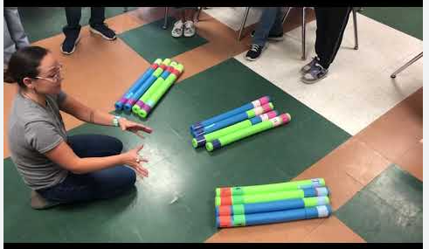 |  | Lesson Look Fors  Look for teachers to:  - Allow students to productively struggle with the content, using accountable talk moves to facilitate the lesson.  - Asking probing questions throughout the presentation that pushes students’ thinking.  Look for students to:  - Ask clarifying questions regarding what they are learning  - Write in complete sentences  Students Do and Know
   | - Model the phases of meiosis with peers.  - Determine genotypes and phenotypes based on which sperm fertilized a particular egg.
   | - Meiosis is the process by which gametes (sperm and egg) are made.  - Meiosis has 2 divisions which produces 4 daughter cells created from one mother cell.  - Each daughter cell is haploid; it contains half the number of chromosomes as the mother cell.  - Crossing over, independent assortment, and random fertilization increase genetic variability in the population.
Science Practices
Concept Explanation
Visual Representations
Argumentation

Lesson #2: Meiosis Gizmo |  | Date:
Objective  SWBAT: Describe how meiosis leads to an increase in genetic diversity.  Standards  Topic 5.1  Topic 5.2  Vocabulary  - Meiosis I  - Prophase I  - Metaphase I  - Anaphase I  - Telophase I  - Meiosis II  - Prophase II  - Metaphase II  - Anaphase II  - Telophase II  - Gametes  - Genotype  - Phenotype | Instructional Notes  Students will participate in a Gizmo where they will learn the following:  - Learn the steps in meiosis and compare meiosis in male and female cells.  - Distinguish between mitosis and meiosis.  - Describe how genetic diversity is created through crossovers and random assortment of homologous chromosomes.  - Use crossovers to design gametes to produce offspring with specific traits.  In the Meiosis Gizmo, students will observe the steps of meiosis, compare the process in male and female cells, and discover what can go wrong. They will use crossovers to produce diverse sets of gametes and create offspring with specific genotypes and phenotypes.  The Student Exploration sheet contains four activities:  - Activity A – Students learn the steps of meiosis in male cells and observe how meiosis is different from mitosis.  - Activity B – Students compare meiosis in female cells to meiosis in male cells.  - Activity C – Students observe how genetic diversity is created in gametes using crossovers and independent assortment of chromosomes.  - Activity D – Students experiment with crossovers in fruit fly sex cells to produce offspring with specific genotypes and phenotypes. |  | Lesson Look Fors  Look for teachers to:  - Allow students to productively struggle with the content, using accountable talk moves to facilitate the lesson.  - Asking probing questions throughout the presentation that pushes students’ thinking.  Look for students to:  - Engage in the online simulation and fill out the student document.  - Ask clarifying questions regarding what they are learning  - Write in complete sentences  Students Do and Know
  - Interact with the simulation and answer questions regarding concepts learned.
  - Investigate each step of meiosis and determine the resulting genotype and phenotype.
  - Make conclusions based on models seen.
  - Meiosis is the process by which gametes (sperm and egg) are made.
  - Meiosis has 2 divisions which produces 4 daughter cells created from one mother cell.
  - Each daughter cell is haploid; it contains half the number of chromosomes as the mother cell.
  - Crossing over, independent assortment, and random fertilization increase genetic variability in the population.
Science Practices
Concept Explanation
Visual Representations
Questions and Methods
Representing and Describing Data
Statistical Tests and Data Analysis
Argumentation

Lesson #3: Meiosis vs Mitosis Activity |  | Date:
Objective  SWBAT: Analyze models to determine similarities and differences between mitosis and meiosis.  Standards  Topic 5.1  Topic 5.2  Vocabulary  - Meiosis I and II  - Prophase I and II  - Metaphase I and II  - Anaphase I and II  - Telophase I and II  - Prophase  - Metaphase  - Anaphase  - Telophase  - Cytokinesis  - Gametes  - Genotype  - Phenotype | Instructional Notes  Students will watch a very short video where they will see both mitosis and meiosis take place. They will then participate in an activity where they model both mitosis and meiosis. They can either work individually or work in pairs. Every student must fill out their own document.  Ensure that students are writing FULL sentences on all parts of this activity. This is about learning to write effectively as much as it is about the difference between mitosis and meiosis.  Give your students colored pencils, markers, or crayons. We want them to construct colorful models.  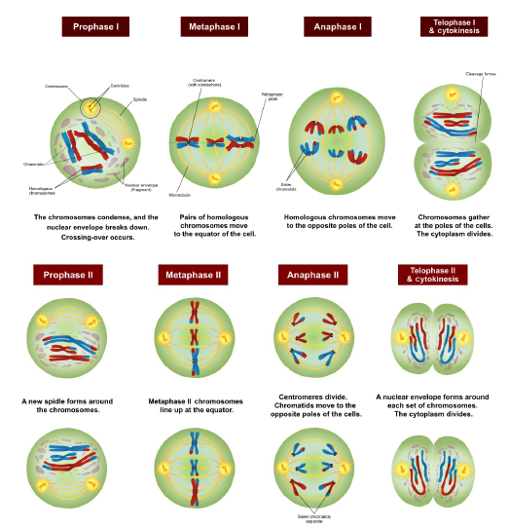 |  | Lesson Look Fors  Look for teachers to:  - Allow students to productively struggle with the content, using accountable talk moves to facilitate the lesson.  - Asking probing questions throughout the presentation that pushes students’ thinking.  Look for students to:  - Ask clarifying questions regarding what they are learning  - Write in complete sentences  Students Do and Know
  - Analyze models of mitosis and meiosis for similarities and differences.
  - Meiosis is the process by which gametes (sperm and egg) are made.
  - Meiosis has 2 divisions which produces 4 daughter cells created from one mother cell.
  - Each daughter cell is haploid; it contains half the number of chromosomes as the mother cell.
  - Crossing over, independent assortment, and random fertilization increase genetic variability in the population.
  - Mitosis is the process by which somatic cells are replicated.
  - Mitosis has only one division and produces two daughter cells.
  - Mitosis produces diploid daughter cells from a diploid mother cells (daughter cells have the same amount of chromosomes as the mother cell.)
Science Practices
Concept Explanation
Visual Representations
Argumentation
Lesson #4: HHMI Sickle Cell Activity – Day 1 |  | Date:
Objective  SWBAT: Use models to investigate the effect of sickle cell anemia.  Standards  Topic 5.1, 5.2, 5.3, and 5.4  Vocabulary  - Law of Dominance  - Law of Segregations  - Law of Independent Assortment  - Homozygous dominant  - Homozygous recessive  - Heterozygous  - Allele  - Gene  - Gamete  - Genotype  - Phenotype | Instructional Notes  This classroom lesson uses the information presented in the short film The Making of the Fittest: Natural Selection in Humans (https://www.biointeractive.org/classroom-resources/sickle-cell-natural-selection-humans) to take students through a series of questions pertaining to the genetics of sickle cell disease and its relationship to malaria resistance. The questions are divided into sections: “Mendelian Genetics and Probability,” “Pedigrees,” and “Chi-Square Statistics.” Within each section, the questions sequentially move from a basic level to a more advanced level in order to develop the skills of the students.  Students will be able to  - use Punnett squares to predict the frequencies of genotypes in the next generation based on the genotypes of the parents  - understand the rules of probability as they relate to genetics problems  - analyze pedigrees to deduce genotypes, phenotypes, and probabilities  - use the chi-square statistical analysis test to determine the significance of genetics data  This activity will take 2 days to complete. On Day 1, students will watch the video and complete questions 1-5.  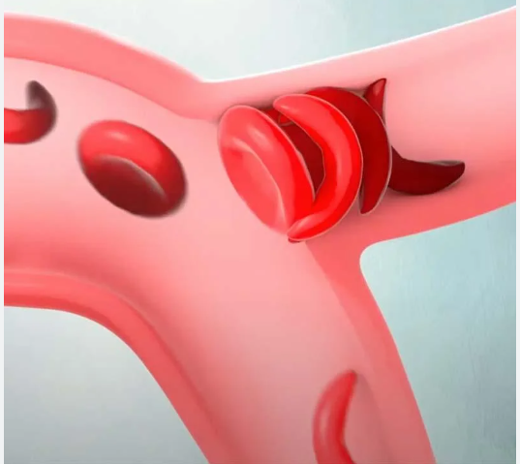 |  | Lesson Look Fors  Look for teachers to:  - Allow students to productively struggle with the content, using accountable talk moves to facilitate the lesson.  - Asking probing questions throughout the presentation that pushes students’ thinking.  Look for students to:  - Ask clarifying questions regarding what they are learning  - Write in complete sentences  Students Do and Know
  - Investigate a real-world genetic disorder.
  - Use Mendelian genetics techniques to determine possible genotype and phenotypes of potential crosses.
  - Use probabilities to determine the chance of passing on a potentially deadly allele.
  - Having two of the same alleles of a given gene means an individual is homozygous; if the alleles are not identical, then the individual is heterozygous.
  - The sickle cell allele arose as a random mutation in the hemoglobin gene.
  - Individuals who are homozygous for the sickle cell allele have sickle cell disease; individuals who are homozygous for the normal hemoglobin allele do not have sickle cell disease but can contract malaria.
  - Individuals who are heterozygous for the sickle cell allele are protected against malaria but do not get sickle cell disease. Heterozygous individuals have a mix of normal and abnormal hemoglobin molecules.
Science Practices
Concept Explanation
Visual Representations
Representing and Describing Data
Argumentation
Lesson #5: HHMI Sickle Cell Activity – Day 2 |  | Date:
Objective  SWBAT: Use probabilities and chi-square to analyze data to determine the significance of data gathered on sickle-cell anemia in a population.  Standards  Topic 5.1  Topic 5.2  Topic 5.3  Topic 5.4  Vocabulary  - Vocabulary from Day 1  - Non-mendelian  - Sex-linked  - Codominance  - Incomplete dominance  - Multiple Alleles | Instructional Notes  This classroom lesson uses the information presented in the short film The Making of the Fittest: Natural Selection in Humans (https://www.biointeractive.org/classroom-resources/sickle-cell-natural-selection-humans) to take students through a series of questions pertaining to the genetics of sickle cell disease and its relationship to malaria resistance. The questions are divided into sections: “Mendelian Genetics and Probability,” “Pedigrees,” and “Chi-Square Statistics.” Within each section, the questions sequentially move from a basic level to a more advanced level in order to develop the skills of the students.  Students will be able to  - use Punnett squares to predict the frequencies of genotypes in the next generation based on the genotypes of the parents  - understand the rules of probability as they relate to genetics problems  - analyze pedigrees to deduce genotypes, phenotypes, and probabilities  - use the chi-square statistical analysis test to determine the significance of genetics data  This activity will take 2 days to complete. On Day 2, the students will complete questions 6-12.  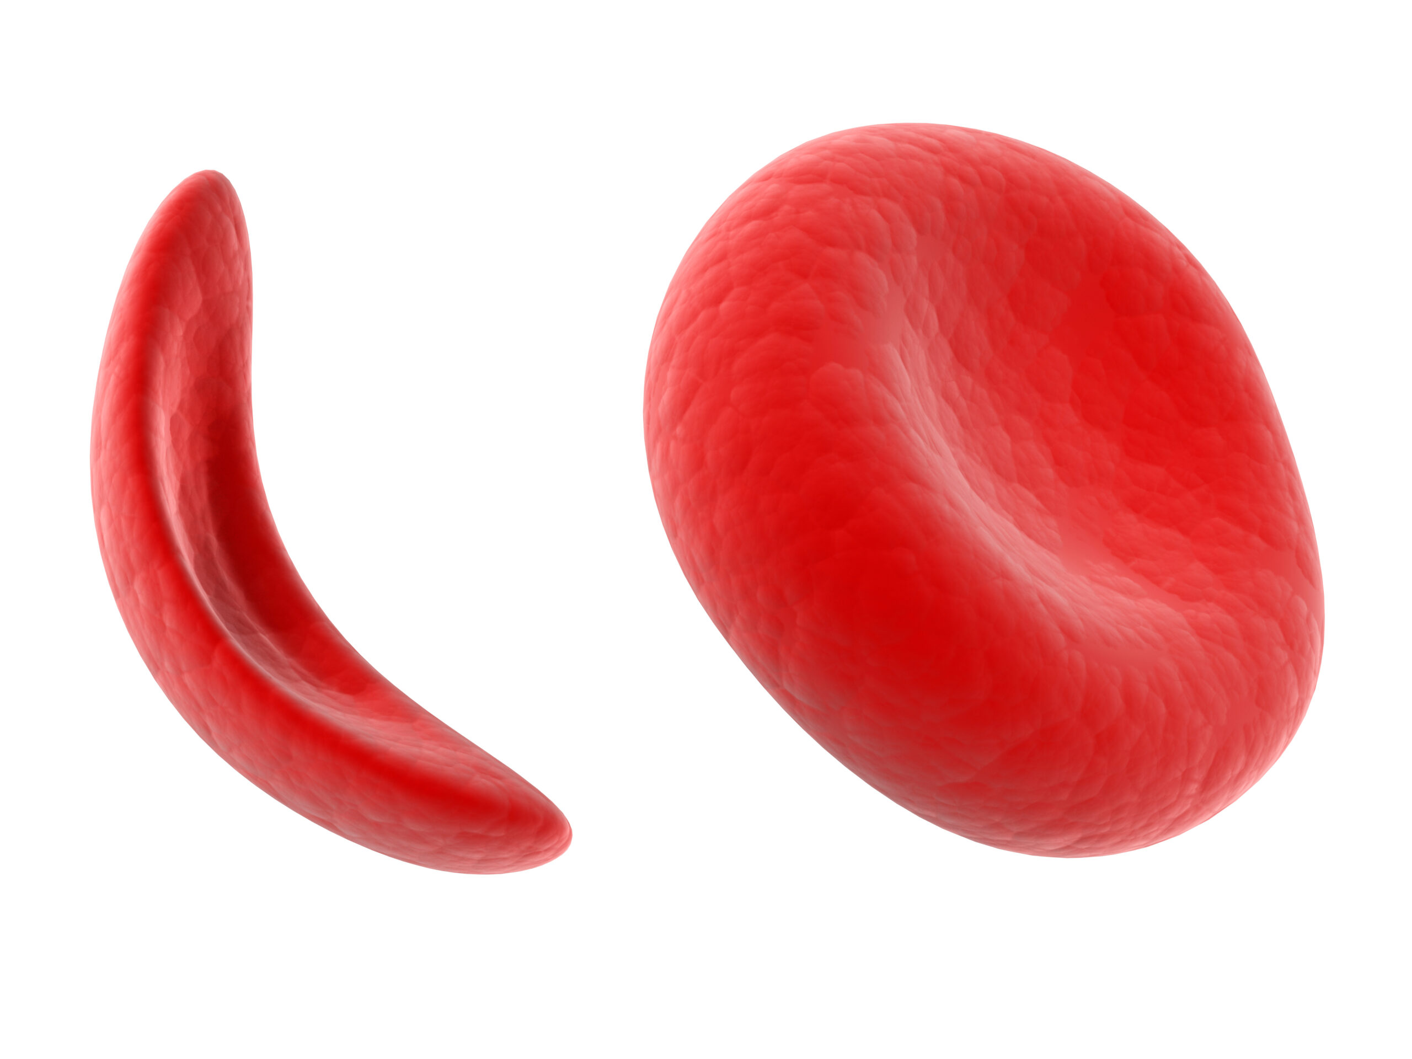 |  | Lesson Look Fors  Look for teachers to:  - Allow students to productively struggle with the content, using accountable talk moves to facilitate the lesson.  - Asking probing questions throughout the presentation that pushes students’ thinking.  Look for students to:  - Ask clarifying questions regarding what they are learning  - Write in complete sentences  Students Do and Know
  - Investigate a real-world genetic disorder.
  - Use Mendelian genetics techniques to determine possible genotype and phenotypes of potential crosses.
  - Use probabilities to determine the chance of passing on a potentially deadly allele.
  - Use chi-square analysis to determine the validity of data.
  - Having two of the same alleles of a given gene means an individual is homozygous; if the alleles are not identical, then the individual is heterozygous.
  - The sickle cell allele arose as a random mutation in the hemoglobin gene.
  - Individuals who are homozygous for the sickle cell allele have sickle cell disease; individuals who are homozygous for the normal hemoglobin allele do not have sickle cell disease but can contract malaria.
  - Individuals who are heterozygous for the sickle cell allele are protected against malaria but do not get sickle cell disease. Heterozygous individuals have a mix of normal and abnormal hemoglobin molecules.
Science Practices
Concept Explanation
Visual Representations
Representing and Describing Data
Statistical Tests and Data Analysis
Argumentation
Lesson #6: Linkage Day! |  | Date:
Objective  SWBAT: Determine the distance of two genes on a chromosome based on their recombination frequency.  Standards  Topic 5.4  Vocabulary  - Genetic recombination  - Map distance  - Linked vs unlinked genes  - Recombination frequency | Instructional Notes  Activity #1: Hand out the “Linked Genes Artifact.” Students will watch a video on linked genes and take notes. You may want to stop the video and answer any questions that they might have. After the video, go over the artifact with them explaining the concepts of linkage and how it affects diversity.  Activity 2: Students will practice linked genes using the Linkage Map Worksheet. When they are done, go over the correct answers with them. Push students to give appropriate justification (rationale) for their answers. They need to be able to articulate the processes that they are using to arrive at the answers.  Activity #3: Students will complete a Linked Genes Activity (Answer Key); this time you can take it up as a gradable assignment.  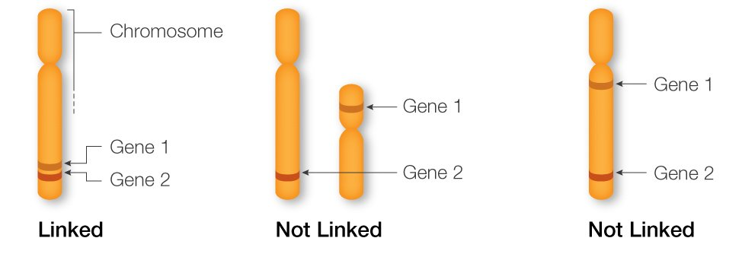 |  | Lesson Look Fors  Look for teachers to:  - Allow students to productively struggle with the content, using accountable talk moves to facilitate the lesson.  - Asking probing questions throughout the presentation that pushes students’ thinking.  Look for students to:  - Ask clarifying questions regarding what they are learning  - Write in complete sentences  Students Do and Know
  - Interact with models to gain clarity on content.
  - Articulate (and write) an explanation of the importance of recombination in a population’s survival.
  - Linked genes are so close together on the chromosome that they cross over together during Prophase I.
  - Genetic recombination is the process by which DNA sequences are rearranged, resulting in new combinations of alleles in offspring.
  - Geneticists routinely convert recombination frequencies into cM: the recombination frequency in percent is approximately the same as the map distance in cM. The longer the map distance, the higher the recombination frequency.
Science Practices
Concept Explanation
Visual Representations
Representing and Describing Data
Statistical Tests and Data Analysis
Argumentation

Lesson #7: Genetics Problems Practice |  | Date:
Objective  SWBAT: Analyze scenarios to determine how certain genes are inherited.  Standards  Topic 5.1, Topic 5.2, Topic 5.3, Topic 5.4  Vocabulary  - Homozygous dominant  - Homozygous recessive  - Heterozygous  - Allele  - Gamete  - Genotype  - Phenotype  - Sex-linked  - Codominance  - Incomplete dominance  - Multiple Alleles | Instructional Notes  Activity #1: Students will have the chance to work on some sample genetics problems, representing both Mendelian and non-Mendelian genetics.  Activity #2: Students will participate in a highlight and rewrite activity. A HLRW activity is one where students answer a prompt, then highlight where they got points, analyze where they were correct and where they missed the mark, and then rewrite with a perfect response.  - Teacher hands student a free response prompt.  - Student answers the question to the best of their ability.  - Teacher gives students the rubric by which the question should be scored on and then takes a highlighter and highlights everywhere in their writing that earned a point. The teacher can help clarify if individual students have questions.  - Student then analyzes their answer for the following:  - Where did I earn points, and why was I able to earn them?  - Where did I not earn points, and why was I not able to earn them?  - What vocabulary and/or concepts did I not know and/or got confused on?  - Then, the student takes their analysis, along with the rubric, and writes a perfect response.  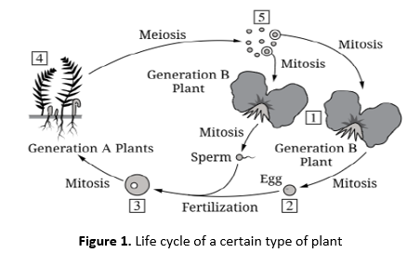 |  | Lesson Look Fors  Look for teachers to:  - Allow students to productively struggle with the content, using accountable talk moves to facilitate the lesson.  - Asking probing questions throughout the presentation that pushes students’ thinking.  Look for students to:  - Ask clarifying questions regarding what they are learning  - Write in complete sentences  Students Do and Know
  - Use techniques to solve genetics problems.
  - Participate in a highlight and rewrite activity to sharpen writing skills.
  - Genetics is the study of how genes and how traits are passed down from one generation to the next.
  - Mendel's laws of inheritance include law of dominance, law of segregation and law of independent assortment.
  - Non-mendelian genetics involves the pattern of inheritance that does not follow Mendel's laws, such as multiple alleles, sex-linked, codominance, and incomplete dominance.
  - A Punnett square is a diagram that predicts the probability of offspring genotypes from a genetic cross between two individuals.
Science Practices
Concept Explanation
Visual Representations
Questions and Methods
Representing and Describing Data
Statistical Tests and Data Analysis
Argumentation

Day 8 | Flex Day
Day 9 | Review Day
Day 10 | Unit 4 Exam

UNPACKED STANDARDS
Focus standards for this unit.

Standards Clarification
Standards | Specificity | Notes/Explanations/Examples
5.1.A: Explain how meiosis results in the transmission of chromosomes from one generation to the next. | Cognition: Explain  Content: Provide information about how or why a relationship, process, pattern, position, situation, or outcome occurs, using evidence and/or reasoning to support or qualify a claim. Explain “how” typically requires analyzing the relationship, process, pattern, position, situation, or outcome; whereas explain “why” typically requires analysis of motivations or reasons for the relationship, process, pattern, position, situation, or outcome. | Concept Explanation (SP 1.B)  Explain biological concepts and/or processes  Resources:  Classroom resources: Meiosis Lab
5.1.B: Describe similarities and/or differences between phases and outcomes of mitosis and meiosis | Cognition: Describe  Content: Provide relevant characteristics of a specified topic.
5.2.A: Explain how the process of meiosis generates genetic diversity. | Cognition: Explain  Content: Provide information about how or why a relationship, process, pattern, position, situation, or outcome occurs, using evidence and/or reasoning to support or qualify a claim. Explain “how” typically requires analyzing the relationship, process, pattern, position, situation, or outcome; whereas explain “why” typically requires analysis of motivations or reasons for the relationship, process, pattern, position, situation, or outcome. | Questions and Methods (SP 3.A)  Identify or pose a testable question based on an observation, data, or a model.  Resources:  Classroom resources: Meiosis Lab
5.3.A: Explain the inheritance of genes and traits as described by Mendel’s laws. |  | Statistical Tests and Data Analysis (SP 5.C)  - Perform mathematical calculations, including means.  Argumentation  - Predict the causes or effects of a change in, or disruption to, one or more components in a biological system.
5.4.A: Explain deviations from Mendel’s model of the inheritance of traits. |  | Illustrative Examples:  - Sex-linked genes reside on sex chromosomes.  - In mammals and flies, females are XX and males are XY; as such, X-linked recessive traits are always expressed in males.  In certain species, the chromosomal basis of sex determination is not based on X and Y chromosomes (such as ZW in birds, haplodiploidy in bees).

VOCABULARY GLOSSARY
Domain-specific words and definitions for this unit.
Key Content Vocabulary
Allele – term coined to describe a specific copy of a gene.

Crossing over – During meiosis, when homologous chromosomes are paired together, there are points along the chromosomes that contact the other pair. This point of contact is deemed the chiasmata and can allow the exchange of genetic information between chromosomes. This further increases genetic variation.

Daughter cell – Daughter cells are cells that result from the division of a single parent cell.

Dihybrid cross – A dihybrid cross describes a mating experiment between two organisms that are identically hybrid for two traits.

Diploid – (of a cell or nucleus) containing two complete sets of chromosomes, one from each parent.

Diversity – the state of being diverse; variety.

Fertilization – the action or process of fertilizing an egg, female animal, or plant, involving the fusion of male and female gametes to form a zygote.

Gamete – Gametes are an organism's reproductive cells. They are also referred to as sex cells. Female gametes are called ova or egg cells, and male gametes are called sperm. Gametes are haploid cells, and each cell carries only one copy of each chromosome. ... These cells develop into sperm or ova.

Gene – (in informal use) a unit of heredity which is transferred from a parent to offspring and is held to determine some characteristic of the offspring.

Genetics – Genetics is the study of heredity in general and of genes in particular. Genetics forms one of the central pillars of biology and overlaps with many other areas, such as agriculture, medicine, and biotechnology.

Genotype – the genetic constitution of an individual organism.

Haploid – (of a cell or nucleus) having a single set of unpaired chromosomes.

Homologous chromosomes – A homologous chromosome pertains to one of a pair of chromosomes with the same gene sequence, loci, chromosomal length, and centromere location.

Karyotype – A karyotype is an individual's collection of chromosomes

Law of Independent assortment – Mendelian law stating that for every pair of unit factors, each of them would assort independently into the newly formed gametes

Law of segregation – ‘‘The two copies of each genetic factor segregate during the development of gametes, to ensure that each parent’s offspring attains one factor.’’ OR
‘‘During the development of the gamete, each gene is segregated in such a way that the gamete consists of just one allele for that gene.’’

Linked genes – Genes that are inherited together with the other gene(s) as they are located on the same chromosome.

Meiosis – the process of cell division that results in the production of a haploid “daughter” cell with a haploid chromosomal number of a diploid “parent” (“original”) cell.

Meiosis I – The first of the two consecutive divisions of the nucleus of eukaryotic cell during meiosis, and composed of the following stages: prophase I, metaphase I, anaphase I, and telophase I

Meiosis II – The second of the two consecutive divisions of the nucleus of eukaryotic cell during meiosis, and composed of the following stages: prophase II, metaphase II, anaphase II, and telophase II

Mitosis – Mitosis is a process where a single cell divides into two identical daughter cells (cell division). During mitosis one cell? divides once to form two identical cells. The major purpose of mitosis is for growth and to replace worn out cells.

Monohybrid – A monohybrid cross is a cross between two organisms with different variations at one genetic locus of interest. The character(s) being studied in a monohybrid cross are governed by two or multiple variations for a single locus.

Mother cell – In cell division, a mother or parent cell is the cell that divides to give rise to two daughter cells. In mitosis, the two daughter cells contain the same genetic content as the mother cell.

Nondisjunction – the failure of one or more pairs of homologous chromosomes or sister chromatids to separate normally during nuclear division, usually resulting in an abnormal distribution of chromosomes in the daughter nuclei.

Pedigree – A pedigree chart is a diagram that shows the occurrence and appearance of phenotypes of a particular gene or organism and its ancestors from one generation to the next, most commonly humans, show dogs, and racehorses.

Phenotype – used to describe a visible trait or characteristic

Plasticity – the adaptability of an organism to changes in its environment or differences between its various habitats.

Sex-linked inheritance – Sex linked describes the sex-specific patterns of inheritance and presentation when a gene mutation is present on a sex chromosome rather than a non-sex chromosome. In humans, these are termed X-linked recessive, X-linked dominant and Y-linked.

Variation – the occurrence of an organism in more than one distinct color or form.

Zygote – a diploid cell resulting from the fusion of two haploid gametes; a fertilized ovum.

